
Virginia Real Est at e Board
http:lj www.dpor.virginia.gov/Consumers/Di sclosure Forms/

RESIDENTIAL PROPERTY DISCLOSURE STATEMENT
ACKNOWLEDGEMENT BY SELLER AND PURCHASER

' Virgi( 1
of
i9) j
cl1, | it  .... t
;1' d | it  .... t

The Virginia R esid ential Property Disclosure Act(§ 55-517 et seq. of the |  | Code
owner of certain residential real prop rty-whenever the property is to | be sold

as,
e
er l
r
e A, .
i
'.
equ [res
h an option
the
.

b .y·• \.th
o .r
f er the
·
ss+-s : d: l ·, .
at io
n
ll
1
to buy- to provide notification to the purchaser of any disclosures required
1
purchaser to thP Real Estate Board WE·bsit e referenced below for additional | info | rm
Cert ain t ran sfer s of residential property are excluded from this requirement | (se §

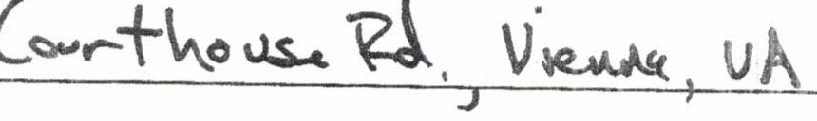
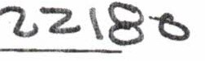
PROPERTY ADDRESS/ LEGAL DESCRIPTION:

The purchaser is advised to consult the RESIDENTIAL PROPERTY DISCLOSURE STATEMENT webpage (http://www.dpor.virginia.gov/Consumers/Residential Property Disclosures) for important information about disclosures required by law that may affect the buyer's decision to purchase the real property described above.

The owner(s) hereby provides notification as required under the Virgini a Re sid ential Property Disclosure Act(§ 55-517 et seq. of the Code of Virginia) and, if re presented by a real estate licensee as provided in§ 55-523, further acknowledges having been informed of
the rights a eAct.
C) v Jl{J ZP
Owner Owner

Date Date

The purchaser(s) hereby acknowledges receipt of notificatio n of disclosures as required under the Virginia Residential Property Disclosure Act (§ 55-517 et seq. of the Code of Virginia). In addition, if the purchaser is (i) represented by a real estat e licensee or
(ii) notrepresented by a real esta licensee but the owner is so represented as provided in
§ 55-523, the purchaser further acknowledges having been informed of the rights and obligations under the Act.

Purchaser Purchaser

Date Date
DPOR rev 07/10/17 v3.11

lnstanet FoR MS·

