- RESIDENTS BUSINESS GOVERNMENT SERVICES CONNECT
CONTACT US I (t
PROPERTY SEARCHQ.

Address Map Number Map Search Search Home

Profile Sales l(alues
Tax Details Residential Commercial Map
Structure Size
MAP#: 0384 02 0073
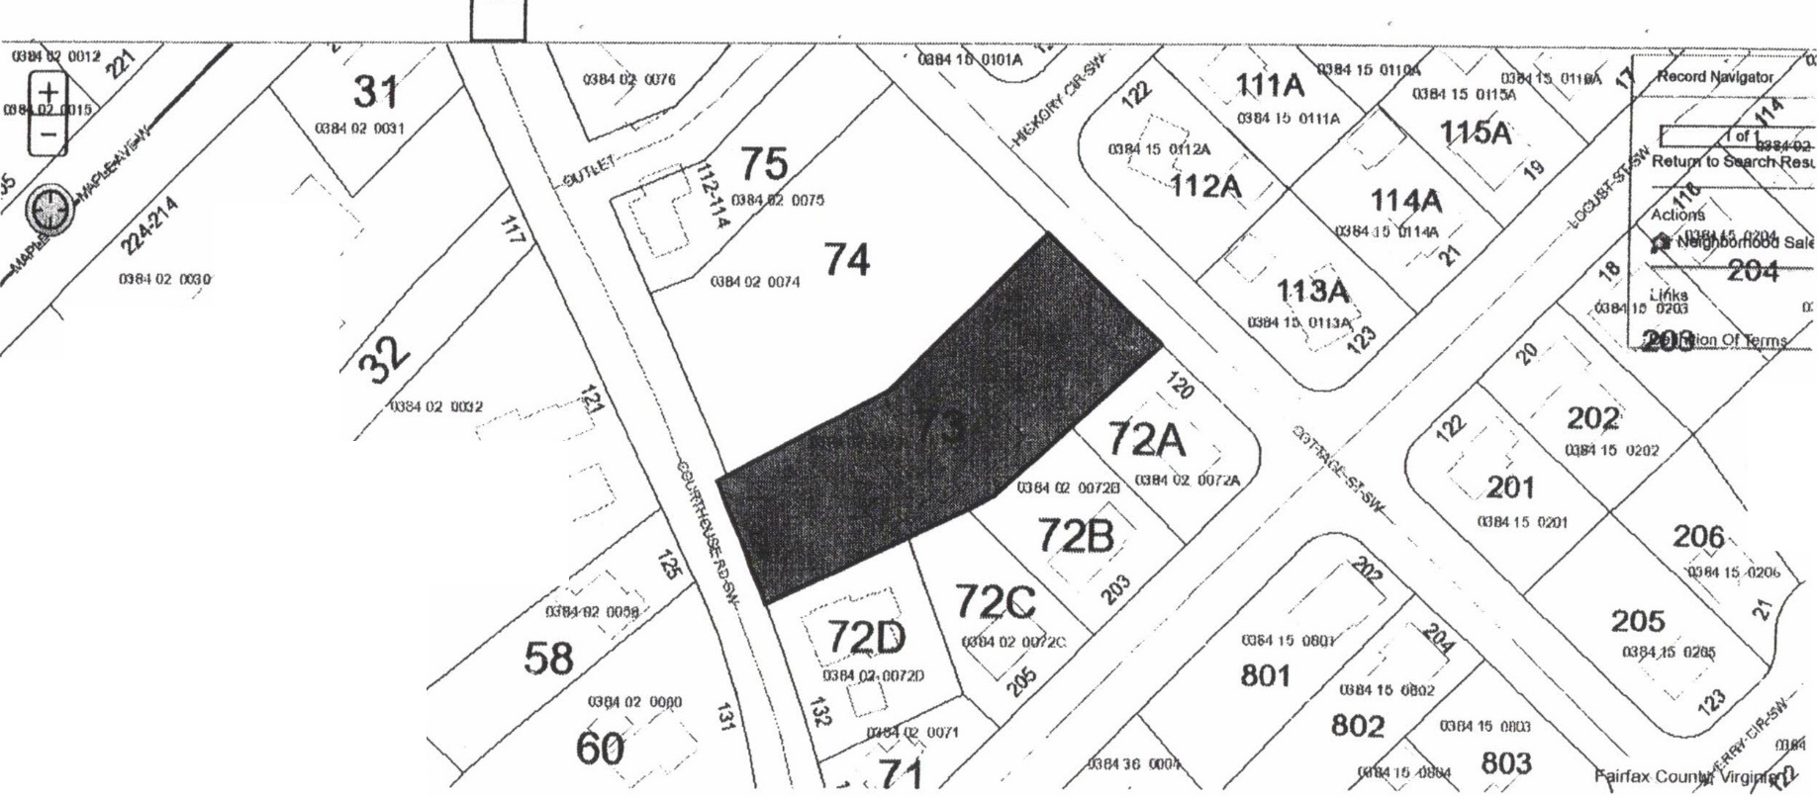
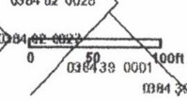
COLE LAURIE GENEVRO 124 COURTHOUSI
/
/
3-0 '
/
'·,..
/
/
/
, · . /'
\ /
2(9A .J
'
,·
·'
2(
mo,,,1.
'\_ll
( ,/
/ _/
mll4 02 no:'J'r 57
0384 02 0111.9,\
28
000]

« RESI DENTS BUSINESS GOVERNMENT SERVICES CONNECT
CONTACT US ! (!£
PROPERTY SEARCH Q

Address Map Number Map Search Search Home

Profile Sales Values
Tax Details Residential Commercial Map
Structure Size
MAP #: 0384 02 0073
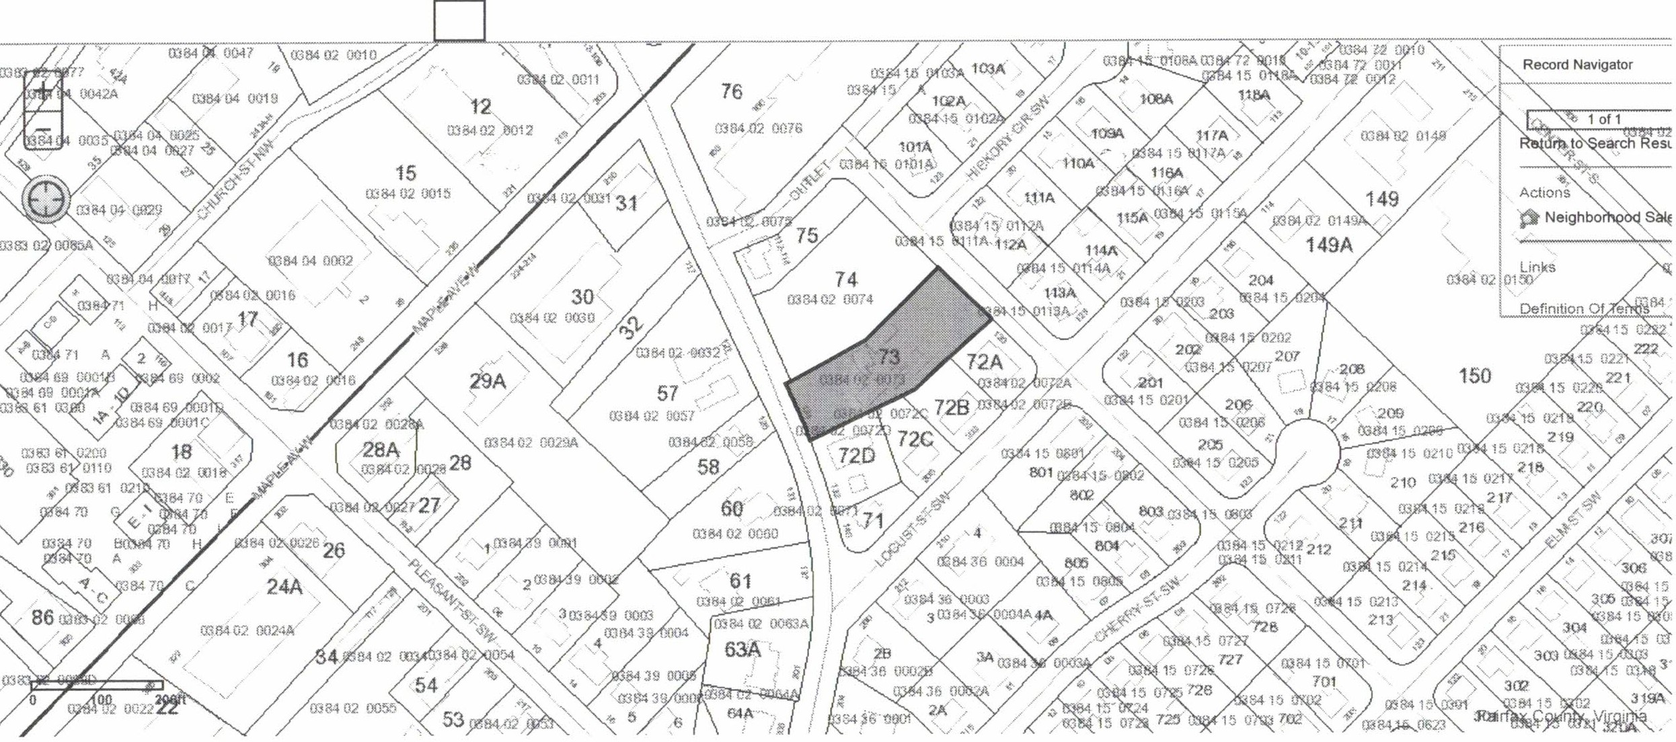
COLE LAURIE GENEVRO 124 COURTHOUSI

, ; _ ,.

