r
  - Form 4-6844 (Home Lrum)
Revised December 1949. Use Optional.
Servicemen's Readjustm,ent ,Act
.;i; (88 U'. S. C• .A. 694 (a)).
- Acceptable to RFC Morts;age Co,
- 1.279



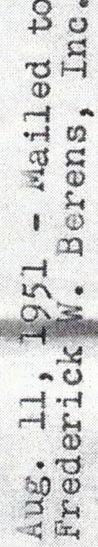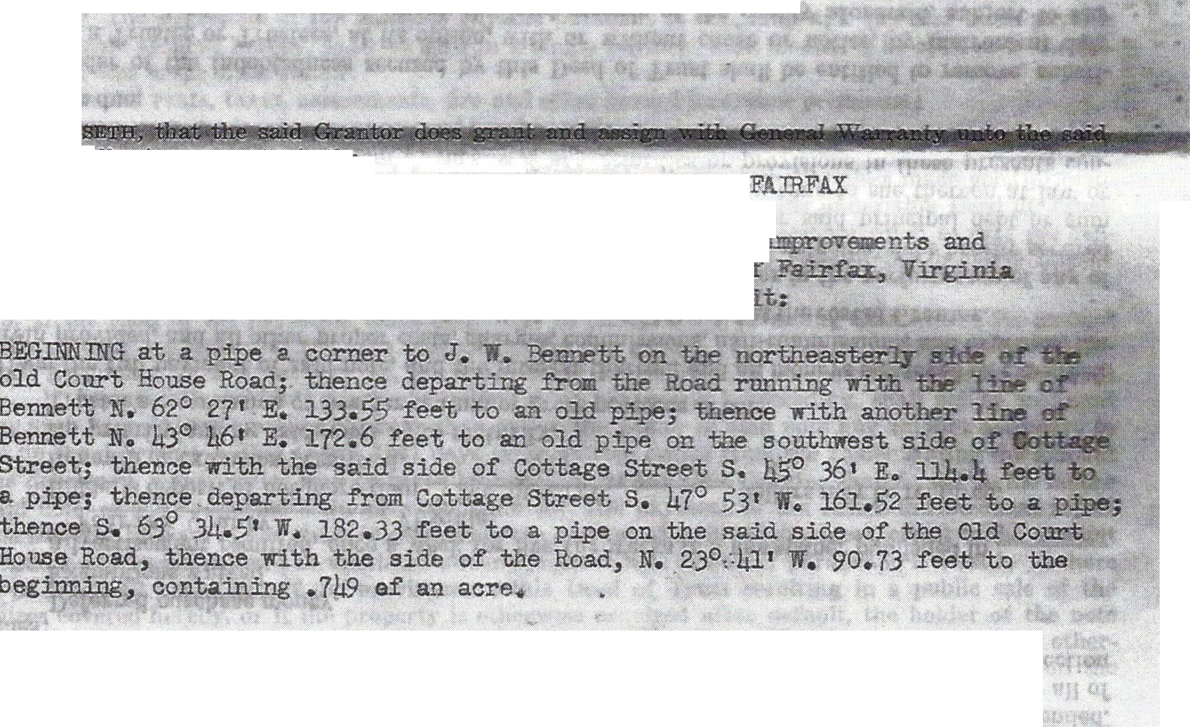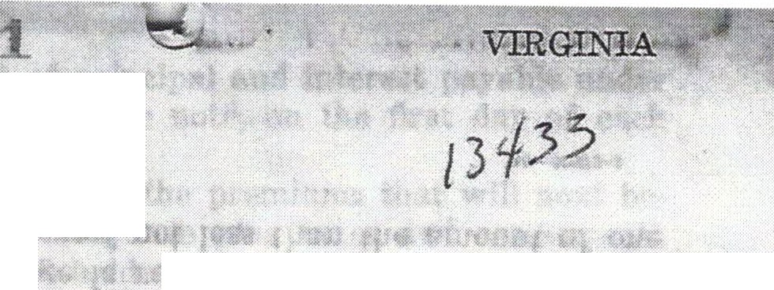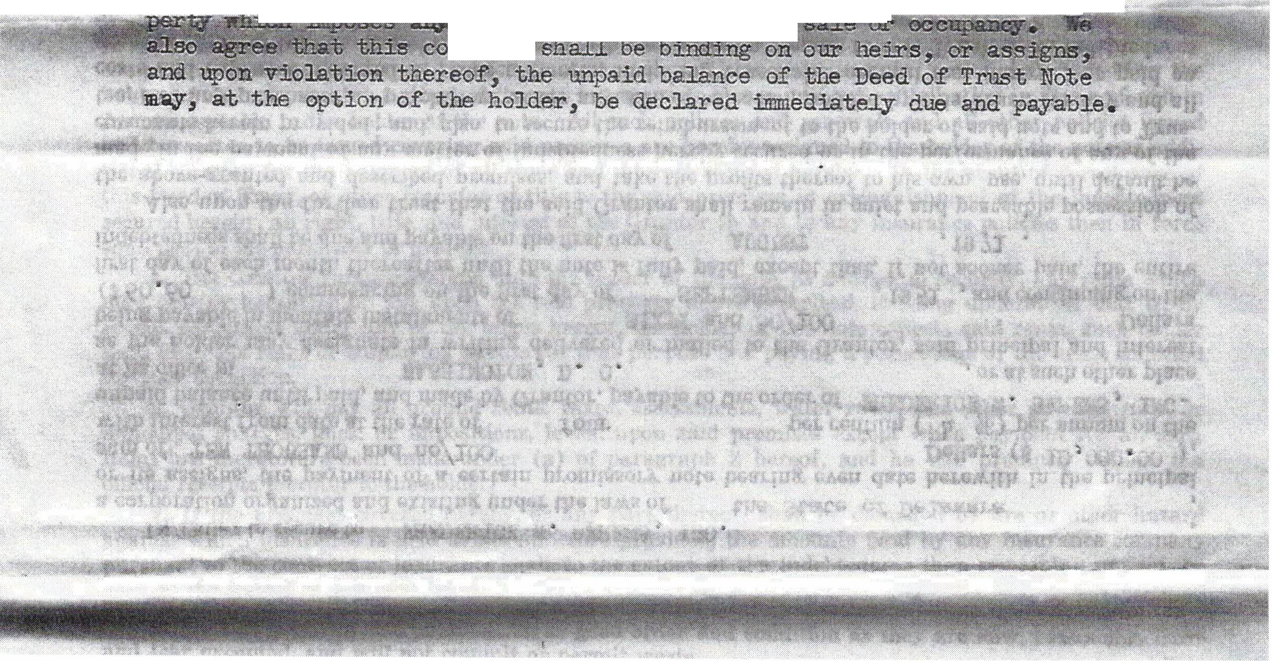.. DEED OE TRUST
or e>.xeeute aJJ1" agreement, lease or conveyance a.ff e.et ing
.
*
.
tbe mortgage,ii pro-
THJS D , made this 28th day of JULY , 1 in th e year 1#51 , betw en
    - OOINSON, a:R and Y.tt.ID F. ROBINSON, his p:te, as tenants by 'tae ..
,
Granto1:. and E1ANC'JS . ifro:rsoN JR.. and J .. HANSOH BW.L

Trustee (s) :

'.Frust'ee the following property, in tlie

of " eounty of
a"nd:state ef Virginia., to wit;
  - . All 0f tl;ia:t l.ot or p eel 0£ grotmi, iMether 1fijm its ·
a.p;p'Ul'telila?i1£e , ;:beea't .ed ilil. t TGJm of ism1a, o·:

11 d being More parti ularJ.Y -G.eseribea. as oll t.e--wit:



 Wn.til W,e Note, secured by i>eed ef Trust s bee:q. paid ·n .f'aJ+, or atn: r,r:i:se terminated', we will not file for record any rest:ri.ctio:n upori the sa.Ie or occupancy of the mortgaged proper-cy on the basis of race, color or ereed

