CONTACT US ! et,

11 RESIDENTS BUSINESS GOVERNMENT SERVICES CONNECT PROPERTY SEARCH O.

Address Map Number Map Search Search Home

Profile Sales Values
Tax Details Residential Commercial Map
Structure Size
MAP #: 0384 02 0073

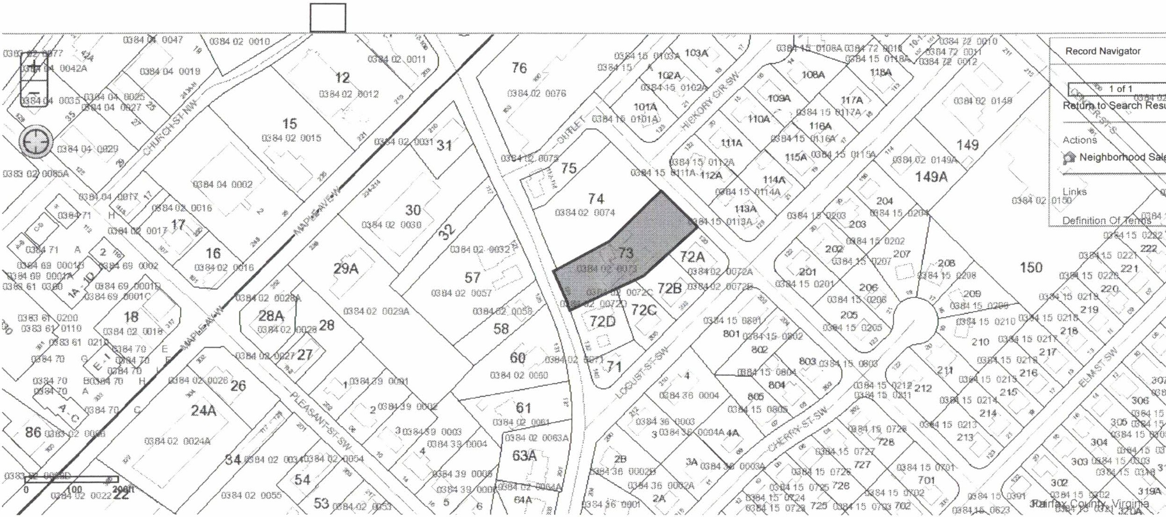
COLE LAURIE GENEVRO 124 COURTHOUSI

J;_ :,

